
NAME- Vibhum Bhattad
PRN NO- 202501050037

PRACTICAL NO.3
Write a Pythonprogramtocreate a NumPy array based on user input and
display the following:
The created NumPy array.
The number of dimensions of the array using ndim
The shape of the array using shape
The total number of elements in the array using size
Assume all input elements are valid integers.
Input Format:
The first line contains two space-separated integers, and , representing
the number of rows and the number of columns.
The next lines contain space-separated integers representing the
elements of the array, entered row by row.
Output Format:
The created NumPy array (printed as a 2D array).
An integer representing the number of dimensions of the array.
A tuple representing the shape of the array.
An integer representing the total number of elements in the array
CODE:


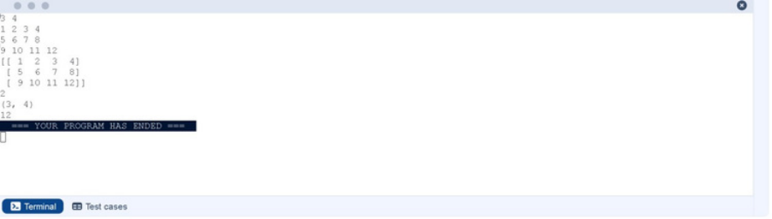
import numpy as np
r,c = map(int, input().split())
elements = []
foriinrange(r):
row= list(map(int, input().split()))
elements.extend(row)
arr=np.array(elements).reshape(r, c)
print(arr)
print(arr.ndim)
print(arr.shape)
print(arr.size)
OUTPUT:


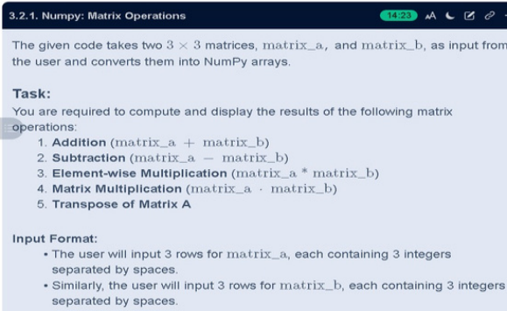
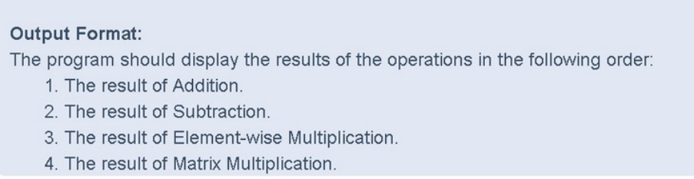
CODE:
importnumpy as np
#Input matrices
print("Enter Matrix A:")
matrix_a = np.array([list(map(int, input().split())) for i in range(3)])
print("Enter Matrix B:")
matrix_b = np.array([list(map(int, input().split())) for i in range(3)])


# Addition
addition_result = matrix_a + matrix_b
print("Addition (A + B):")
print(addition_result)
# Subtraction
subtraction_result = matrix_a - matrix_b
print("Subtraction (A - B):")
print(subtraction_result)
# Multiplication (element-wise)
elementwise_multiplication_result = matrix_a * matrix_b
print("Element-wise Multiplication (A * B):")
print(elementwise_multiplication_result)
# Matrix multiplication (dot product)
matrix_multiplication_result = np.dot(matrix_a, matrix_b)
print("A dot B:")
print(matrix_multiplication_result)
# Transpose
transpose_a = matrix_a.T
print("Transpose of A:")
print(transpose_a)


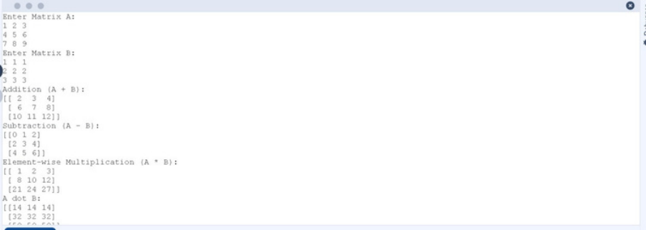
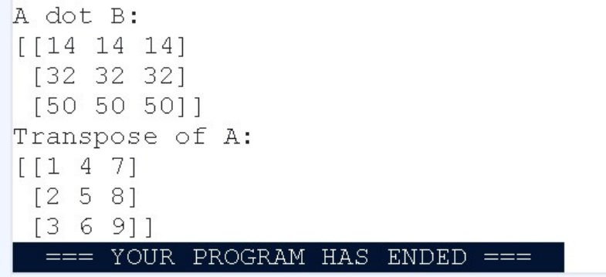
OUTPUT:


You are given two arrays arr1 and arr2. You need to perform horizontal and
vertical stacking operations on them using NumPy.
Horizontal Stacking: Stack the two matrices horizontally (side by side).
Vertical Stacking: Stack the two matrices vertically (one below the
other).
Input Format:
The program should first prompt the user to input two 3x3 arrays.
Each array consists of 3 rows, and each row contains 3 space-separated
integers.
The user will input the two arrays row by row.
Output Format:
The program should display the result of the Horizontal Stack (side-by-
side stacking) of the two arrays.
The program should then display the result of the Vertical Stack (one
below the other) of the two arrays.
CODE:
import numpy as np
#Input matrices
print("Enter Array1:")
arr1 = np.array([list(map(int, input().split())) for i in range(3)])
print("Enter Array2:")
arr2 = np.array([list(map(int, input().split())) for i in range(3)])
# Perform horizontal stacking (hstack)


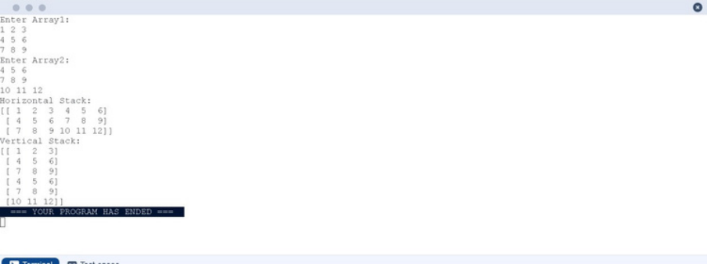
h_stack = np.hstack((arr1, arr2))
#Perform vertical stacking (vstack)
v_stack = np.vstack((arr1, arr2))
#Output results
print("Horizontal Stack:")
print(h_stack)
print("Vertical Stack:")
print(v_stack)
OUTPUT:


Write a Python program that takes the following inputs from the user:
Start value: The starting point of the sequence.
Stop value: The sequence should end before this value.
Step value: The increment between each number in the sequence.
The program should then generate a sequence using numpy based on these
inputs and print the generated sequence.
Input Format:
The user will input three integer values: start, stop, and step, each on a
new line.
Output Format:
The program should print the generated sequence based on the input
values.
CODE:
import numpy as np
#Take user input for the start, stop, and step of the sequence
start = int(input())
stop = int(input())
step = int(input())


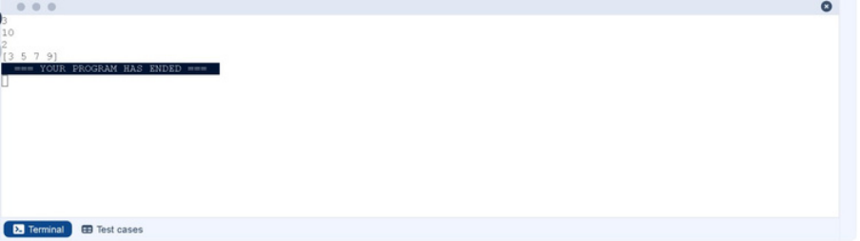
# Generate the sequence using np.arange()
sequence = np.arange(start, stop, step)
#Print the generated sequence
print(sequence)
OUTPUT:


You are given two arrays A and B. Your task is to complete the function
array_operations, which will convert these lists into NumPy arrays and
perform the following operations:
1. Arithmetic Operations:
Compute the element-wise sum, difference, and product of the two
arrays.
2. Statistical Operations:
Calculate the mean, median, and standard deviation of array A.
3. Bitwise Operations:
Perform bitwise AND, bitwise OR, and bitwise XOR on the arrays (ex: A i
OR B).
Input Format:
The first line contains space-separated integers representing the
elements of array A.
The second line contains space-separated integers representing the
elements of array B.
Output Format:
For each operation (arithmetic, statistical, and bitwise), print the results
in the specified format as shown in sample test cases.
CODE:
import numpy as np
def array_operations(A, B):
# Convert A and B to NumPy arrays


A = np.array(A)
B = np.array(B)
# Arithmetic Operations
sum_result = A + B
diff_result = A - B
prod_result = A * B
# Statistical Operations
mean_A = np.mean(A)
median_A = np.median(A)
std_dev_A = np.std(A)
# Bitwise Operations
and_result = A & B
or_result = A | B
xor_result = A ^ B
#Output results with one space between each element
print("Element-wise Sum:", ' '.join(map(str, sum_result)))
print("Element-wise Difference:", ' '.join(map(str, diff_result)))
print("Element-wise Product:", ' '.join(map(str, prod_result)))
print(f"Mean of A: {mean_A}")
print(f"Median of A: {median_A}")
print(f"Standard Deviation of A: {std_dev_A}")


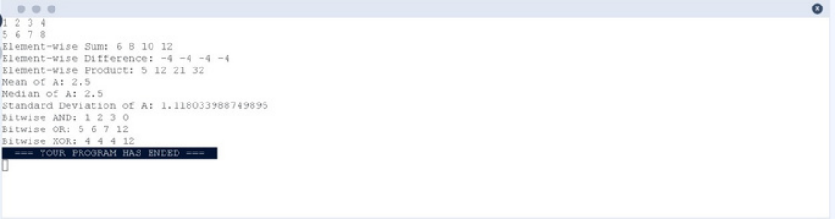
print("Bitwise AND:", ' '.join(map(str, and_result)))
print("Bitwise OR:", ' '.join(map(str, or_result)))
print("Bitwise XOR:", ' '.join(map(str, xor_result)))
A=list(map(int, input().split())) # Elements of array A
B=list(map(int, input().split())) # Elements of array B
array_operations(A, B)
OUTPUT:


The given code takes a list of integers as input and converts it into a NumPy
array. Your task is to complete the code by:
Creating a view of the original_array and assigning it to view_array.
Creating a copy of the original_array and assigning it to copy_array.
After completing these steps, observe how modifying the view affects the
original_array, while modifying the copy does not.
Input Format:
A single line of space-separated integers.
Output Format:
After modifying the view:
Original array after modifying view: <original_array>
View array: <view_array>
After modifying the copy:
Original array after modifying copy: <original_array>
Copy array: <copy_array>
CODE:
import numpy as np
inputlist = list(map(int,input().split(" ")))
#Original array
original_array = np.array(inputlist)


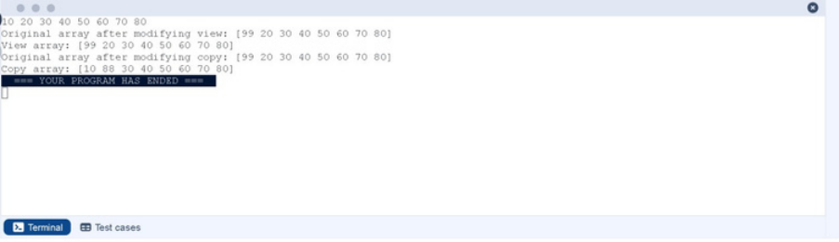
# Create a view
view_array = original_array.view()
#Create a copy
copy_array = original_array.copy()
#Modify the view
view_array[0] = 99
print("Original array after modifying view:", original_array)
print("View array:", view_array)
#Modify the copy
copy_array[1] = 88
print("Original array after modifying copy:", original_array)
print("Copy array:", copy_array)
OUTPUT:


The given code in the editor takes a single array, array1, as space-separated
integers as input from the user.
Additionally, it takes the following inputs:
search_value: The value to search for in the array.
count_value: The value to count its occurrences in the array.
broadcast_value: The value to add for broadcasting across the array.
You need to complete the code to perform the following operations:
1. Searching: Find the indices where search_value appears in array1 and print
these indices.
2. Counting: Count how many times count_value appears in array1 and print
the count.
3. Broadcasting: Add broadcast_value to each element of array1 using
broadcasting, and print the resulting array.
4. Sorting: Sort array1 in ascending order and print the sorted array.
Input Format:
1. A single line containing space-separated integers representing array1.
2. An integer search_value represents the value to search for in the array.
3. An integer count_value represents the value to count in the array.
4. An integer broadcast_value represents the value to add to each element
of the array.
Output Format:
1. The indices where search_value occurs in array1.
2. The count of occurrences of count_value in array1.
3. The array after adding the broadcast_value to each element.
4. The sorted array.


CODE:
importnumpy as np
#Input array from the user
array1 = np.array(list(map(int, input().split())))
#Searching
search_value = int(input("Value to search: "))
count_value = int(input("Value to count: "))
broadcast_value = int(input("Value to add: "))
#Find indices where value matches in array1
indices = np.where(array1 == search_value)[0]
print(indices)
#Count occurrences in array1
count = np.sum(array1 == count_value)
print(count)
#Broadcasting addition
broadcasted = array1 + broadcast_value
print(broadcasted)
# Sort the first array
sorted_array = np.sort(array1)
print(sorted_array)


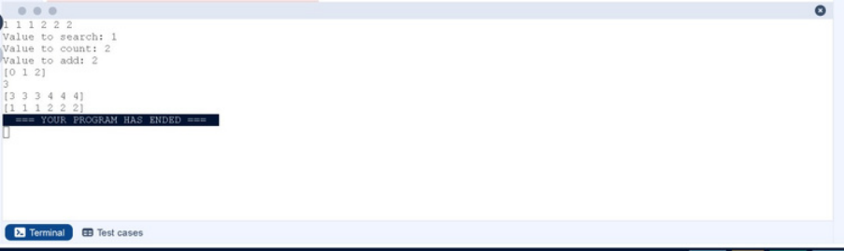
OUTPUT:


Write a Python program that takes the file name of a CSV file containing
student details, including roll numbers and their marks in three subjects
as input, reads the data, and performs the following operations:
Print all student details: Display the complete details of all students,
including roll numbers and marks for all subjects.
Find total students: Determine the total number of students in the
dataset.
Print all student roll numbers: Extract and print the roll numbers of all
students.
Print Subject 1 marks: Extract and print the marks of all students in
Subject 1.
Find minimum marks in Subject 2: Identify the lowest marks in Subject
2.
Find maximum marks in Subject 3: Identify the highest marks in Subject
3.
Print all subject marks: Display the marks of all students for each
subject.
Find total marks of students: Compute the total marks for each student
across all subjects.
Find the average marks of each student: Compute the average marks for
each student.
Find average marks of each subject: Compute the average marks for all
students in each subject.
Find average marks of Subject 1 and Subject 2: Compute the average
marks for Subject 1 and Subject 2.
Find average marks of Subject 1 and Subject 3: Compute the average
marks for Subject 1 and Subject 3.
Find the roll number of the student with maximum marks in Subject 3:
Identify the student with the highest marks in Subject 3 and print their
roll number.


Find the roll number of the student with minimum marks in Subject 2:
Identify the student with the lowest marks in Subject 2 and print their
roll number.
Find the roll number of students who scored 24 marks in Subject 2:
Identify students who obtained exactly 24 marks in Subject 2 and print
their roll numbers.
Find the count of students who got less than 40 marks in Subject 1:
Count the number of students who scored less than 40 marks in Subject
1.
Find the count of students who got more than 90 marks in Subject 2:
Count the number of students who scored more than 90 marks in
Subject 2.
Find the count of students who scored >=90 in each subject: Count the
number of students who scored 90 or more marks in each subject.
Find the count of subjects in which each student scored >=90:
Determine how many subjects each student scored 90 or more marks in.
Print Subject 1 marks in ascending order: Sort and print the marks of
students in Subject 1 in ascending order.
Print students who scored between 50 and 90 in Subject 1: Display
students who scored marks between 50 and 90 in Subject 1.
Find index positions of students who scored 79 in Subject 1: Identify the
index positions of students who scored exactly 79 marks in Subject 1.
CODE:
import numpy as np
a= np.loadtxt("Sample.csv", delimiter=',', skiprows=1)
#1
print("All student Details:\n", a)
# 2


print("Total Students:", a.shape[0])
# 3
print("All Student Roll Nos", a[:, 0])
# 4
print("Subject 1 Marks", a[:, 1])
# 5
print("Min marks in Subject 2", np.min(a[:, 2]))
# 6
print("Max marks in Subject 3", np.max(a[:, 3]))
# 7
print("All subject marks:", a[:, 1:])
# 8
total = np.sum(a[:, 1:], axis=1)
print("Total Marks", total)
# 9 (no label in sample output)
print(np.round(np.mean(a[:, 1:], axis=1), 1))
# 10
print("Average Marks of each subject", np.round(np.mean(a[:, 1:],
axis=0), 1))
# 11
print("Average Marks of S1 and S2", np.round(np.mean(a[:, [1, 2]],
axis=0), 1))
# 12
print("Average Marks of S1 and S3", np.round(np.mean(a[:, [1, 3]],
axis=0), 1))
# 13


print("Roll no who got maximum marks in Subject 3", a[np.argmax(a[:,
3]), 0])
# 14
print("Roll no who got minimum marks in Subject 2", a[np.argmin(a[:,
2]), 0])
# 15
print("Roll no who got 24 marks in Subject 2", a[a[:, 2] == 24,
0].reshape(-1,1))
# 16
print("Count of students who got marks in Subject 1 < 40", np.sum(a[:, 1]
< 40))
# 17
print("Count of students who got marks in Subject 2 > 90:", np.sum(a[:,
2] > 90))
# 18
print("Count of students in each subject who got marks >= 90:",
np.sum(a[:, 1:] >= 90, axis=0))
# 19
print("Roll no:", a[:, 0])
print("Count of subjects in which student got marks >= 90:",
np.sum(a[:, 1:] >= 90, axis=1))
# 20
print(np.sort(a[:, 1]))
# 21 (print full rows like sample)
print(a[(a[:, 1] >= 50) & (a[:, 1] <= 90)])
print(a)
# 22 (exact output format)
print(np.where(a[:, 1] == 79))


OUTPUT:


